**РУСЕНСКИ УНИВЕРСИТЕТ „АНГЕЛ КЪНЧЕВ“**

**КУРСОВА ЗАДАЧА**

ПО

ОПЕРАЦИОННИ СИСТЕМИ

Студент:

Фак. Номер:

Група:

Специалност:

Дата: Проверил:

**Съдържание**

1. Задание 3

2. Описание на използваните структури данни и алгоритми 3

3. Код на програмата (листинг) 4

2.1 Program.cs 4

2.2 FormMain.cs 4

2.3 FormMain.Designer.cs 7

2.4 Process.cs 13

4. Демо 15

# Задание

Да се разработи програмна система, симулираща работата на модула за **управление на процесите** при следните изходни данни:

* ***Основни необходими структури:***
  + Ready таблица на готовите процеси;
  + Blocked таблица на блокираните процеси;
  + Running идентификатор на изпълняващ се процес;
* ***Основни обработки:***
  + Load стартиране на нов процес;
  + Dispatch извикване на диспечер по стратегия FIFO;
  + Finish завършване на изпълняващия се процес;
  + Block блокиране на изпълняващия се процес;
  + Unblock деблокиране на процеса;
  + Show показване на състоянието на основните структури.

Разработеният проект да има подходящ потребителски интерфейс за обръщение към основните обработки. Обяснителната записка да съдържа заданието, описание на използваните структури данни и алгоритми и програмен листинг.

# Описание на използваните структури данни и алгоритми

При дисциплината първи дошъл-първи обслужен (First-Come-First-Served, FCFS), когато един процес стане готов, той се включва в опашката на готовите процеси, а когато текущо изпълняваният процес престане да се изпълнява, избира се за изпълнение процес, който най-дълго е бил в опашката на готовите процеси. Когато текущо изпълняваният процес се блокира, той се включва в опашката на блокираните процеси и чака да настъпи някакво събитие, за да се включи отново в опашката на готовите процеси. Ако процесът завърши изпълнението си се избира следващият процес от опашката на готовите процеси (фигура 1).

Дисциплината FCFS е дисциплина без превключване.

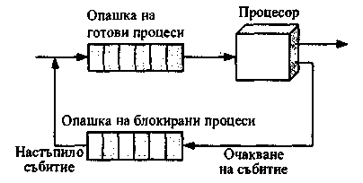

Фигура 1 Диаграма, илюстрираща „управлението на процесите“ при дисциплината FCFS

* Queue<Process> ready; - опашка на готовите процеси;
* Queue<Process> blocked; - опашка на блокираните процеси;
* Process currentProcess; - текущо изпълняваният процес;
* Класът Process се състои от две полета: Id – идентификатор на процеса; Name – име на процеса;
* private void Repaint(int update) – функция за обновяване на данните в таблиците
* private void buttonLoad_Click(object sender, EventArgs e) – за добавяне на нов процес в опашката на готовите процеси
* private void buttonDispatch_Click(object sender, EventArgs e) – за диспечиране по FCFS (стартиране на процеса)
* private void buttonFinish_Click(object sender, EventArgs e) – за завършване на текущо изпълняваният процес
* private void buttonBlock_Click(object sender, EventArgs e) – за блокиране на текущо изпълняваният процес
* private void buttonUnblock_Click(object sender, EventArgs e) – за деблокиране на процес

# Код на програмата (листинг)



## Program.cs

namespace OS_Process_Management_FIFO

{

using System;

using System.Windows.Forms;

static class Program

{

[STAThread]

static void Main()

{

Application.EnableVisualStyles();

Application.SetCompatibleTextRenderingDefault(false);

Application.Run(new FormMain());

}

}

}

## FormMain.cs

namespace OS_Process_Management_FIFO

{

using System;

using System.Collections.Generic;

using System.Windows.Forms;

public partial class FormMain : Form

{

Queue<Process> ready;

Queue<Process> blocked;

Process currentProcess;

int processCounter;

public FormMain()

{

InitializeComponent();

ready = new Queue<Process>();

blocked = new Queue<Process>();

currentProcess = null;

processCounter = 0;

}

private void Repaint(int update)

{

// 1 - ready

// 2 - blocked

// != 1 and 2 - both

BindingSource bsReady = new BindingSource();

BindingSource bsBlocked = new BindingSource();

switch (update)

{

case 1:

bsReady.DataSource = ready;

dataGridView1.DataSource = bsReady;

break;

case 2:

bsBlocked.DataSource = blocked;

dataGridView2.DataSource = bsBlocked;

break;

default:

bsReady.DataSource = ready;

dataGridView1.DataSource = bsReady;

bsBlocked.DataSource = blocked;

dataGridView2.DataSource = bsBlocked;

break;

}

}

private void buttonLoad_Click(object sender, EventArgs e)

{

string processName = textBoxProcessName.Text.Trim();

if (!String.IsNullOrEmpty(processName))

{

ready.Enqueue(new Process(++processCounter, processName));

buttonDispatch.Enabled = true;

Repaint(1);

}

}

private void buttonDispatch_Click(object sender, EventArgs e)

{

if (currentProcess == null && ready.Count > 0)

{

currentProcess = ready.Dequeue();

buttonDispatch.Enabled = false;

labelCurrentProcess.Text = currentProcess.Id + ", " + currentProcess.Name;

buttonFinish.Enabled = true;

buttonBlock.Enabled = true;

Repaint(1);

}

}

private void buttonFinish_Click(object sender, EventArgs e)

{

if (currentProcess != null)

{

currentProcess = null;

labelCurrentProcess.Text = "~";

buttonBlock.Enabled = false;

if (ready.Count > 0)

{

buttonDispatch.Enabled = true;

}

buttonFinish.Enabled = false;

}

}

private void buttonBlock_Click(object sender, EventArgs e)

{

if (currentProcess != null)

{

blocked.Enqueue(currentProcess);

Repaint(2);

buttonBlock.Enabled = false;

buttonFinish.Enabled = false;

if (ready.Count > 0)

{

buttonDispatch.Enabled = true;

}

buttonUnblock.Enabled = true;

labelCurrentProcess.Text = "~";

currentProcess = null;

}

}

private void buttonUnblock_Click(object sender, EventArgs e)

{

if (blocked.Count > 0)

{

ready.Enqueue(blocked.Dequeue());

if (currentProcess == null)

{

buttonDispatch.Enabled = true;

}

if (blocked.Count == 0)

{

buttonUnblock.Enabled = false;

}

Repaint(0);

}

}

}

}

## FormMain.Designer.cs

namespace OS_Process_Management_FIFO

{

partial class FormMain

{

/// <summary>

/// Required designer variable.

/// </summary>

private System.ComponentModel.IContainer components = null;

/// <summary>

/// Clean up any resources being used.

/// </summary>

/// <param name="disposing">true if managed resources should be disposed; otherwise, false.</param>

protected override void Dispose(bool disposing)

{

if (disposing && (components != null))

{

components.Dispose();

}

base.Dispose(disposing);

}

#region Windows Form Designer generated code

/// <summary>

/// Required method for Designer support - do not modify

/// the contents of this method with the code editor.

/// </summary>

private void InitializeComponent()

{

this.splitContainer1 = new System.Windows.Forms.SplitContainer();

this.splitContainer2 = new System.Windows.Forms.SplitContainer();

this.tableLayoutPanel1 = new System.Windows.Forms.TableLayoutPanel();

this.label1 = new System.Windows.Forms.Label();

this.dataGridView1 = new System.Windows.Forms.DataGridView();

this.tableLayoutPanel2 = new System.Windows.Forms.TableLayoutPanel();

this.label2 = new System.Windows.Forms.Label();

this.dataGridView2 = new System.Windows.Forms.DataGridView();

this.labelCurrentProcess = new System.Windows.Forms.Label();

this.label4 = new System.Windows.Forms.Label();

this.buttonUnblock = new System.Windows.Forms.Button();

this.buttonBlock = new System.Windows.Forms.Button();

this.buttonFinish = new System.Windows.Forms.Button();

this.buttonDispatch = new System.Windows.Forms.Button();

this.buttonLoad = new System.Windows.Forms.Button();

this.textBoxProcessName = new System.Windows.Forms.TextBox();

this.label3 = new System.Windows.Forms.Label();

((System.ComponentModel.ISupportInitialize)(this.splitContainer1)).BeginInit();

this.splitContainer1.Panel1.SuspendLayout();

this.splitContainer1.Panel2.SuspendLayout();

this.splitContainer1.SuspendLayout();

((System.ComponentModel.ISupportInitialize)(this.splitContainer2)).BeginInit();

this.splitContainer2.Panel1.SuspendLayout();

this.splitContainer2.Panel2.SuspendLayout();

this.splitContainer2.SuspendLayout();

this.tableLayoutPanel1.SuspendLayout();

((System.ComponentModel.ISupportInitialize)(this.dataGridView1)).BeginInit();

this.tableLayoutPanel2.SuspendLayout();

((System.ComponentModel.ISupportInitialize)(this.dataGridView2)).BeginInit();

this.SuspendLayout();

//

// splitContainer1

//

this.splitContainer1.Dock = System.Windows.Forms.DockStyle.Fill;

this.splitContainer1.Location = new System.Drawing.Point(0, 0);

this.splitContainer1.Name = "splitContainer1";

//

// splitContainer1.Panel1

//

this.splitContainer1.Panel1.Controls.Add(this.splitContainer2);

this.splitContainer1.Panel1MinSize = 260;

//

// splitContainer1.Panel2

//

this.splitContainer1.Panel2.BackColor = System.Drawing.SystemColors.AppWorkspace;

this.splitContainer1.Panel2.Controls.Add(this.labelCurrentProcess);

this.splitContainer1.Panel2.Controls.Add(this.label4);

this.splitContainer1.Panel2.Controls.Add(this.buttonUnblock);

this.splitContainer1.Panel2.Controls.Add(this.buttonBlock);

this.splitContainer1.Panel2.Controls.Add(this.buttonFinish);

this.splitContainer1.Panel2.Controls.Add(this.buttonDispatch);

this.splitContainer1.Panel2.Controls.Add(this.buttonLoad);

this.splitContainer1.Panel2.Controls.Add(this.textBoxProcessName);

this.splitContainer1.Panel2.Controls.Add(this.label3);

this.splitContainer1.Size = new System.Drawing.Size(674, 500);

this.splitContainer1.SplitterDistance = 260;

this.splitContainer1.TabIndex = 0;

//

// splitContainer2

//

this.splitContainer2.Dock = System.Windows.Forms.DockStyle.Fill;

this.splitContainer2.Location = new System.Drawing.Point(0, 0);

this.splitContainer2.Margin = new System.Windows.Forms.Padding(0);

this.splitContainer2.Name = "splitContainer2";

this.splitContainer2.Orientation = System.Windows.Forms.Orientation.Horizontal;

//

// splitContainer2.Panel1

//

this.splitContainer2.Panel1.BackColor = System.Drawing.SystemColors.AppWorkspace;

this.splitContainer2.Panel1.Controls.Add(this.tableLayoutPanel1);

//

// splitContainer2.Panel2

//

this.splitContainer2.Panel2.BackColor = System.Drawing.SystemColors.AppWorkspace;

this.splitContainer2.Panel2.Controls.Add(this.tableLayoutPanel2);

this.splitContainer2.Size = new System.Drawing.Size(260, 500);

this.splitContainer2.SplitterDistance = 234;

this.splitContainer2.TabIndex = 0;

//

// tableLayoutPanel1

//

this.tableLayoutPanel1.ColumnCount = 1;

this.tableLayoutPanel1.ColumnStyles.Add(new System.Windows.Forms.ColumnStyle(System.Windows.Forms.SizeType.Percent, 100F));

this.tableLayoutPanel1.Controls.Add(this.label1, 0, 0);

this.tableLayoutPanel1.Controls.Add(this.dataGridView1, 0, 1);

this.tableLayoutPanel1.Dock = System.Windows.Forms.DockStyle.Fill;

this.tableLayoutPanel1.Location = new System.Drawing.Point(0, 0);

this.tableLayoutPanel1.Margin = new System.Windows.Forms.Padding(0);

this.tableLayoutPanel1.Name = "tableLayoutPanel1";

this.tableLayoutPanel1.RowCount = 2;

this.tableLayoutPanel1.RowStyles.Add(new System.Windows.Forms.RowStyle());

this.tableLayoutPanel1.RowStyles.Add(new System.Windows.Forms.RowStyle());

this.tableLayoutPanel1.Size = new System.Drawing.Size(260, 234);

this.tableLayoutPanel1.TabIndex = 0;

//

// label1

//

this.label1.Anchor = ((System.Windows.Forms.AnchorStyles)((System.Windows.Forms.AnchorStyles.Left | System.Windows.Forms.AnchorStyles.Right)));

this.label1.AutoSize = true;

this.label1.BackColor = System.Drawing.SystemColors.ControlDark;

this.label1.BorderStyle = System.Windows.Forms.BorderStyle.FixedSingle;

this.label1.Font = new System.Drawing.Font("Microsoft Sans Serif", 9F, System.Drawing.FontStyle.Regular, System.Drawing.GraphicsUnit.Point, ((byte)(204)));

this.label1.Location = new System.Drawing.Point(0, 0);

this.label1.Margin = new System.Windows.Forms.Padding(0);

this.label1.Name = "label1";

this.label1.Size = new System.Drawing.Size(260, 17);

this.label1.TabIndex = 0;

this.label1.Text = "Опашка на готовите процеси";

this.label1.TextAlign = System.Drawing.ContentAlignment.MiddleCenter;

//

// dataGridView1

//

this.dataGridView1.AllowUserToAddRows = false;

this.dataGridView1.AllowUserToDeleteRows = false;

this.dataGridView1.AutoSizeColumnsMode = System.Windows.Forms.DataGridViewAutoSizeColumnsMode.Fill;

this.dataGridView1.BackgroundColor = System.Drawing.SystemColors.ControlLight;

this.dataGridView1.ColumnHeadersHeightSizeMode = System.Windows.Forms.DataGridViewColumnHeadersHeightSizeMode.AutoSize;

this.dataGridView1.Dock = System.Windows.Forms.DockStyle.Fill;

this.dataGridView1.Location = new System.Drawing.Point(0, 17);

this.dataGridView1.Margin = new System.Windows.Forms.Padding(0);

this.dataGridView1.Name = "dataGridView1";

this.dataGridView1.ReadOnly = true;

this.dataGridView1.RowHeadersWidthSizeMode = System.Windows.Forms.DataGridViewRowHeadersWidthSizeMode.AutoSizeToAllHeaders;

this.dataGridView1.SelectionMode = System.Windows.Forms.DataGridViewSelectionMode.FullRowSelect;

this.dataGridView1.Size = new System.Drawing.Size(260, 219);

this.dataGridView1.TabIndex = 1;

//

// tableLayoutPanel2

//

this.tableLayoutPanel2.ColumnCount = 1;

this.tableLayoutPanel2.ColumnStyles.Add(new System.Windows.Forms.ColumnStyle(System.Windows.Forms.SizeType.Percent, 100F));

this.tableLayoutPanel2.Controls.Add(this.label2, 0, 0);

this.tableLayoutPanel2.Controls.Add(this.dataGridView2, 0, 1);

this.tableLayoutPanel2.Dock = System.Windows.Forms.DockStyle.Fill;

this.tableLayoutPanel2.Location = new System.Drawing.Point(0, 0);

this.tableLayoutPanel2.Margin = new System.Windows.Forms.Padding(0);

this.tableLayoutPanel2.Name = "tableLayoutPanel2";

this.tableLayoutPanel2.RowCount = 2;

this.tableLayoutPanel2.RowStyles.Add(new System.Windows.Forms.RowStyle());

this.tableLayoutPanel2.RowStyles.Add(new System.Windows.Forms.RowStyle());

this.tableLayoutPanel2.Size = new System.Drawing.Size(260, 262);

this.tableLayoutPanel2.TabIndex = 1;

//

// label2

//

this.label2.Anchor = ((System.Windows.Forms.AnchorStyles)((System.Windows.Forms.AnchorStyles.Left | System.Windows.Forms.AnchorStyles.Right)));

this.label2.AutoSize = true;

this.label2.BackColor = System.Drawing.SystemColors.ControlDark;

this.label2.BorderStyle = System.Windows.Forms.BorderStyle.FixedSingle;

this.label2.Font = new System.Drawing.Font("Microsoft Sans Serif", 9F, System.Drawing.FontStyle.Regular, System.Drawing.GraphicsUnit.Point, ((byte)(204)));

this.label2.Location = new System.Drawing.Point(0, 0);

this.label2.Margin = new System.Windows.Forms.Padding(0);

this.label2.Name = "label2";

this.label2.Size = new System.Drawing.Size(260, 17);

this.label2.TabIndex = 0;

this.label2.Text = "Опашка на блокираните процеси";

this.label2.TextAlign = System.Drawing.ContentAlignment.MiddleCenter;

//

// dataGridView2

//

this.dataGridView2.AllowUserToAddRows = false;

this.dataGridView2.AllowUserToDeleteRows = false;

this.dataGridView2.AutoSizeColumnsMode = System.Windows.Forms.DataGridViewAutoSizeColumnsMode.Fill;

this.dataGridView2.BackgroundColor = System.Drawing.SystemColors.ControlLight;

this.dataGridView2.ColumnHeadersHeightSizeMode = System.Windows.Forms.DataGridViewColumnHeadersHeightSizeMode.AutoSize;

this.dataGridView2.Dock = System.Windows.Forms.DockStyle.Fill;

this.dataGridView2.Location = new System.Drawing.Point(0, 17);

this.dataGridView2.Margin = new System.Windows.Forms.Padding(0);

this.dataGridView2.Name = "dataGridView2";

this.dataGridView2.ReadOnly = true;

this.dataGridView2.RowHeadersWidthSizeMode = System.Windows.Forms.DataGridViewRowHeadersWidthSizeMode.AutoSizeToAllHeaders;

this.dataGridView2.SelectionMode = System.Windows.Forms.DataGridViewSelectionMode.FullRowSelect;

this.dataGridView2.Size = new System.Drawing.Size(260, 247);

this.dataGridView2.TabIndex = 1;

//

// labelCurrentProcess

//

this.labelCurrentProcess.AutoSize = true;

this.labelCurrentProcess.Font = new System.Drawing.Font("Microsoft Sans Serif", 9F, System.Drawing.FontStyle.Bold, System.Drawing.GraphicsUnit.Point, ((byte)(204)));

this.labelCurrentProcess.Location = new System.Drawing.Point(140, 238);

this.labelCurrentProcess.Name = "labelCurrentProcess";

this.labelCurrentProcess.Size = new System.Drawing.Size(15, 15);

this.labelCurrentProcess.TabIndex = 8;

this.labelCurrentProcess.Text = "~";

//

// label4

//

this.label4.AutoSize = true;

this.label4.Location = new System.Drawing.Point(13, 238);

this.label4.Name = "label4";

this.label4.Size = new System.Drawing.Size(121, 13);

this.label4.TabIndex = 7;

this.label4.Text = "Изпълнява се процес:";

//

// buttonUnblock

//

this.buttonUnblock.Enabled = false;

this.buttonUnblock.Location = new System.Drawing.Point(303, 89);

this.buttonUnblock.Name = "buttonUnblock";

this.buttonUnblock.Size = new System.Drawing.Size(90, 30);

this.buttonUnblock.TabIndex = 6;

this.buttonUnblock.Text = "Деблокиране";

this.buttonUnblock.UseVisualStyleBackColor = true;

this.buttonUnblock.Click += new System.EventHandler(this.buttonUnblock_Click);

//

// buttonBlock

//

this.buttonBlock.Enabled = false;

this.buttonBlock.Location = new System.Drawing.Point(207, 89);

this.buttonBlock.Name = "buttonBlock";

this.buttonBlock.Size = new System.Drawing.Size(90, 30);

this.buttonBlock.TabIndex = 5;

this.buttonBlock.Text = "Блокиране";

this.buttonBlock.UseVisualStyleBackColor = true;

this.buttonBlock.Click += new System.EventHandler(this.buttonBlock_Click);

//

// buttonFinish

//

this.buttonFinish.Enabled = false;

this.buttonFinish.Location = new System.Drawing.Point(111, 89);

this.buttonFinish.Name = "buttonFinish";

this.buttonFinish.Size = new System.Drawing.Size(90, 30);

this.buttonFinish.TabIndex = 4;

this.buttonFinish.Text = "Завършване";

this.buttonFinish.UseVisualStyleBackColor = true;

this.buttonFinish.Click += new System.EventHandler(this.buttonFinish_Click);

//

// buttonDispatch

//

this.buttonDispatch.Enabled = false;

this.buttonDispatch.Location = new System.Drawing.Point(15, 89);

this.buttonDispatch.Name = "buttonDispatch";

this.buttonDispatch.Size = new System.Drawing.Size(90, 30);

this.buttonDispatch.TabIndex = 3;

this.buttonDispatch.Text = "Диспечиране";

this.buttonDispatch.UseVisualStyleBackColor = true;

this.buttonDispatch.Click += new System.EventHandler(this.buttonDispatch_Click);

//

// buttonLoad

//

this.buttonLoad.Location = new System.Drawing.Point(169, 29);

this.buttonLoad.Name = "buttonLoad";

this.buttonLoad.Size = new System.Drawing.Size(80, 23);

this.buttonLoad.TabIndex = 2;

this.buttonLoad.Text = "Стартиране";

this.buttonLoad.UseVisualStyleBackColor = true;

this.buttonLoad.Click += new System.EventHandler(this.buttonLoad_Click);

//

// textBoxProcessName

//

this.textBoxProcessName.Location = new System.Drawing.Point(16, 31);

this.textBoxProcessName.Name = "textBoxProcessName";

this.textBoxProcessName.Size = new System.Drawing.Size(147, 20);

this.textBoxProcessName.TabIndex = 1;

//

// label3

//

this.label3.AutoSize = true;

this.label3.Location = new System.Drawing.Point(13, 15);

this.label3.Name = "label3";

this.label3.Size = new System.Drawing.Size(92, 13);

this.label3.TabIndex = 0;

this.label3.Text = "Име на процеса:";

//

// FormMain

//

this.AutoScaleDimensions = new System.Drawing.SizeF(6F, 13F);

this.AutoScaleMode = System.Windows.Forms.AutoScaleMode.Font;

this.ClientSize = new System.Drawing.Size(674, 500);

this.Controls.Add(this.splitContainer1);

this.Name = "FormMain";

this.StartPosition = System.Windows.Forms.FormStartPosition.CenterScreen;

this.Text = "Управление на процесите";

this.splitContainer1.Panel1.ResumeLayout(false);

this.splitContainer1.Panel2.ResumeLayout(false);

this.splitContainer1.Panel2.PerformLayout();

((System.ComponentModel.ISupportInitialize)(this.splitContainer1)).EndInit();

this.splitContainer1.ResumeLayout(false);

this.splitContainer2.Panel1.ResumeLayout(false);

this.splitContainer2.Panel2.ResumeLayout(false);

((System.ComponentModel.ISupportInitialize)(this.splitContainer2)).EndInit();

this.splitContainer2.ResumeLayout(false);

this.tableLayoutPanel1.ResumeLayout(false);

this.tableLayoutPanel1.PerformLayout();

((System.ComponentModel.ISupportInitialize)(this.dataGridView1)).EndInit();

this.tableLayoutPanel2.ResumeLayout(false);

this.tableLayoutPanel2.PerformLayout();

((System.ComponentModel.ISupportInitialize)(this.dataGridView2)).EndInit();

this.ResumeLayout(false);

}

#endregion

private System.Windows.Forms.SplitContainer splitContainer1;

private System.Windows.Forms.SplitContainer splitContainer2;

private System.Windows.Forms.TableLayoutPanel tableLayoutPanel1;

private System.Windows.Forms.Label label1;

private System.Windows.Forms.DataGridView dataGridView1;

private System.Windows.Forms.TableLayoutPanel tableLayoutPanel2;

private System.Windows.Forms.Label label2;

private System.Windows.Forms.DataGridView dataGridView2;

private System.Windows.Forms.Label labelCurrentProcess;

private System.Windows.Forms.Label label4;

private System.Windows.Forms.Button buttonUnblock;

private System.Windows.Forms.Button buttonBlock;

private System.Windows.Forms.Button buttonFinish;

private System.Windows.Forms.Button buttonDispatch;

private System.Windows.Forms.Button buttonLoad;

private System.Windows.Forms.TextBox textBoxProcessName;

private System.Windows.Forms.Label label3;

}

}

## Process.cs

namespace OS_Process_Management_FIFO

{

public class Process

{

int id;

string name;

public int Id

{

get

{

return id;

}

set

{

id = value;

}

}

public string Name

{

get

{

return name;

}

set

{

name = value;

}

}

public Process(int id, string name)

{

this.Id = id;

this.Name = name;

}

}

}

# Демо

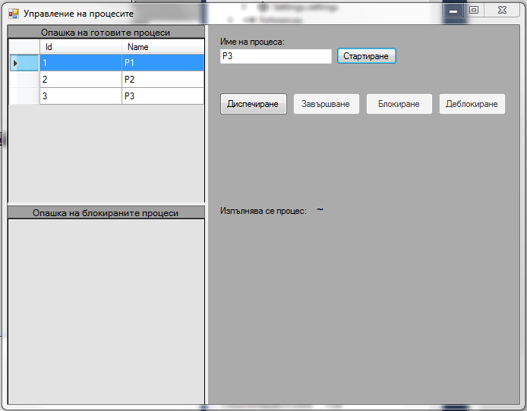

Фигура Има 3 процеса в таблицата на готовите процеси

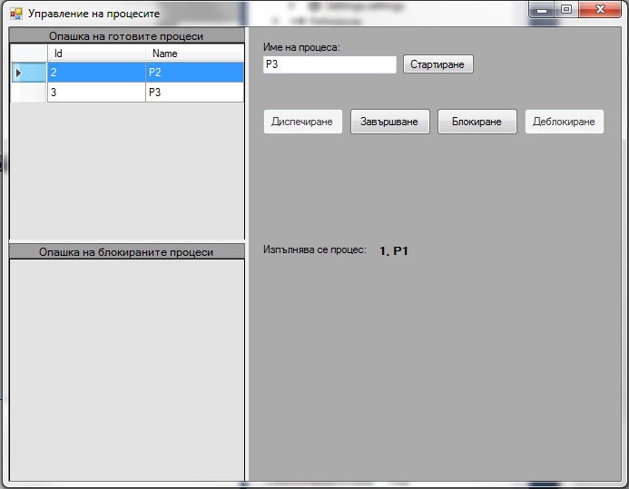

Фигура След избиране на бутон "Диспечиране"

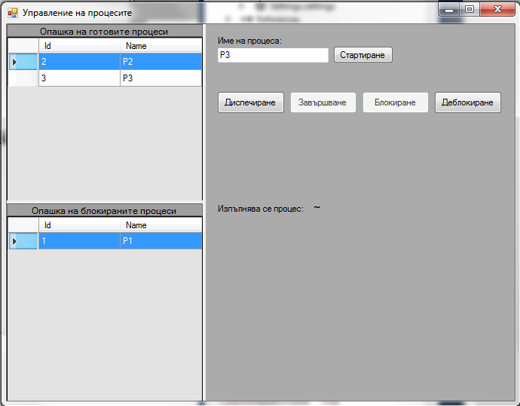

Фигура Процесът е блокиран и е добавен в опашката на блокираните процеси

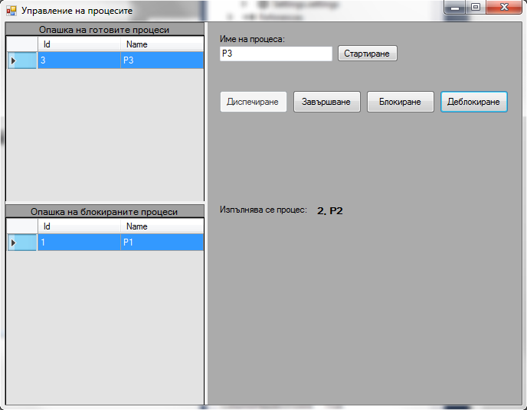

Фигура Изпълнява се друг процес

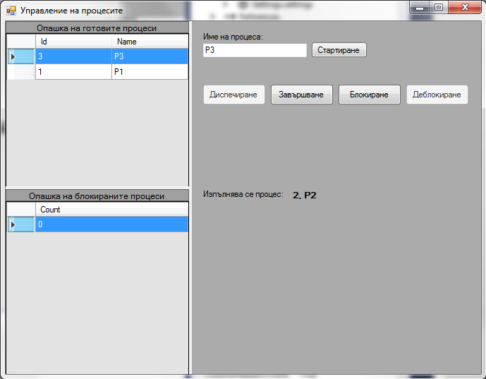

Фигура Деблокиран е процесът в началото на опашката

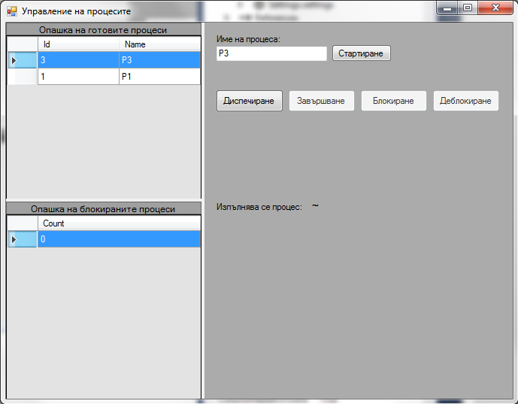

Фигура Изпълняващият се процес е завършен